Before Pre-Processing:

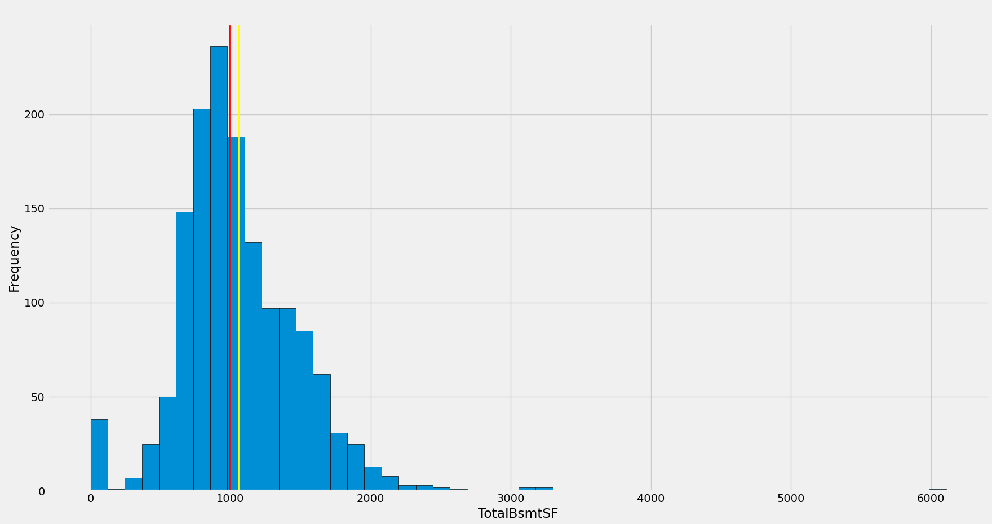

count 1460.000000

mean 1057.429452

std 438.705324

min 0.000000

25% 795.750000

50% 991.500000

75% 1298.250000

max 6110.000000

Skew: 1.5242545490627664

Kurtosis: 13.250483281984796

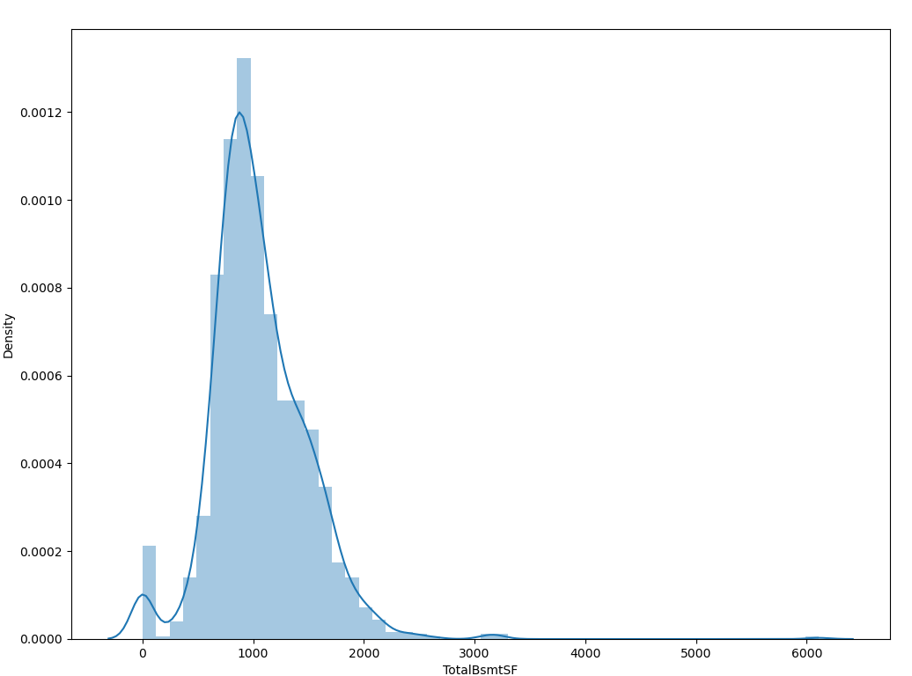

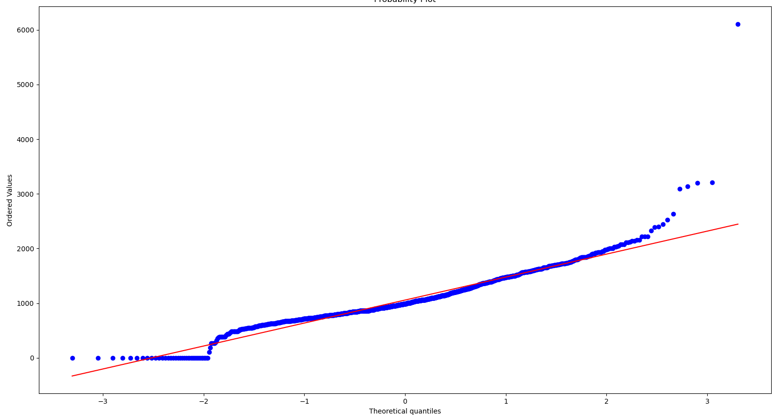

After Log Transform:

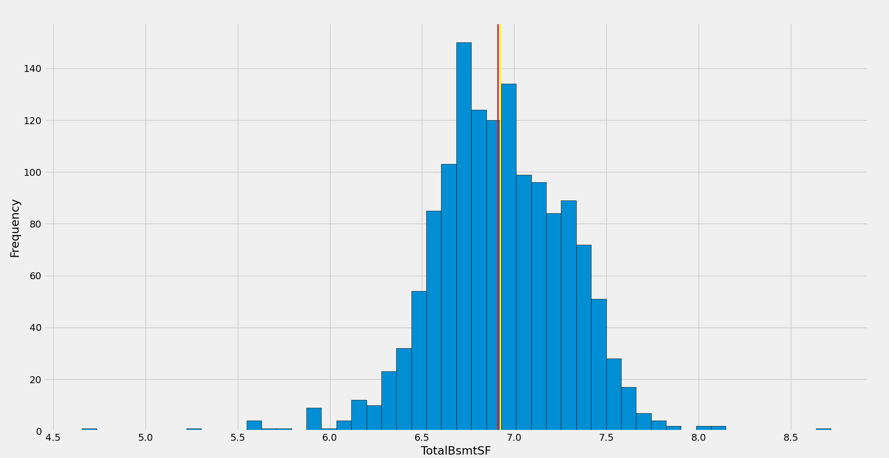

count 1423.000000

mean 6.925031

std 0.361341

min 4.653960

25% 6.697651

50% 6.911747

75% 7.177401

max 8.717682

Skew: -0.27581597237350997

Kurtosis: 1.9346775731369186

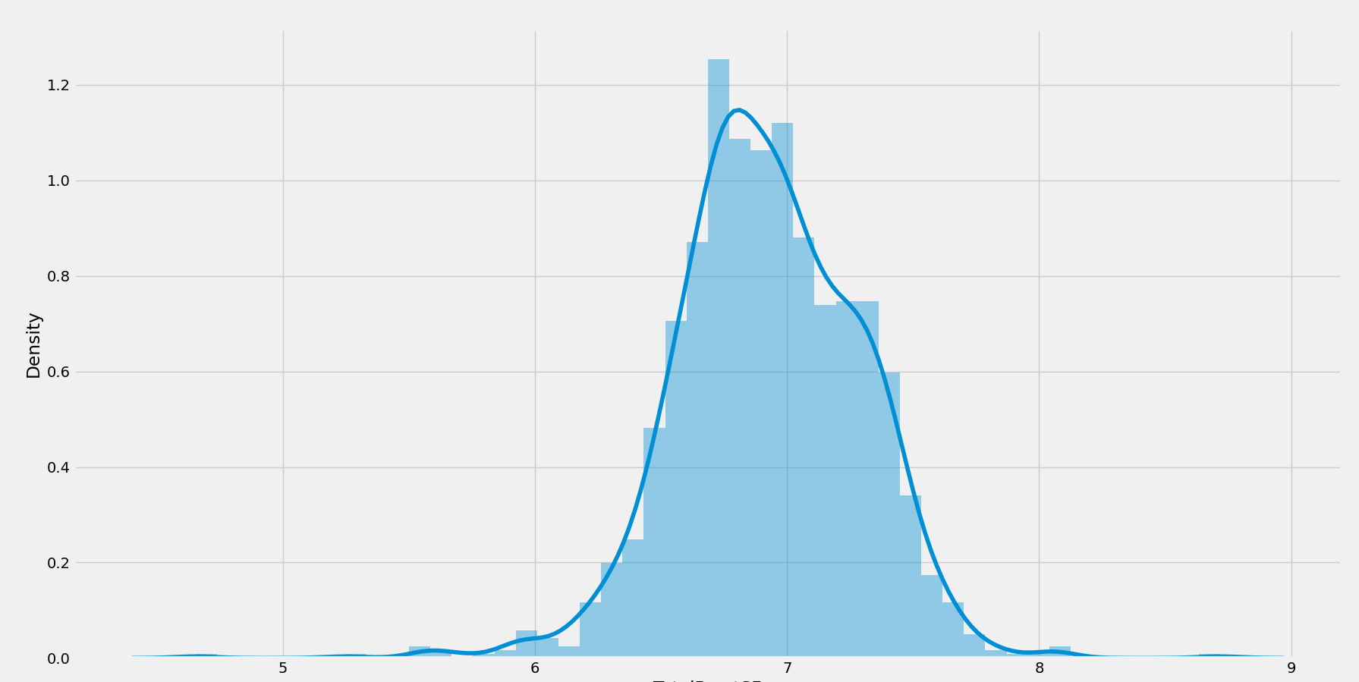

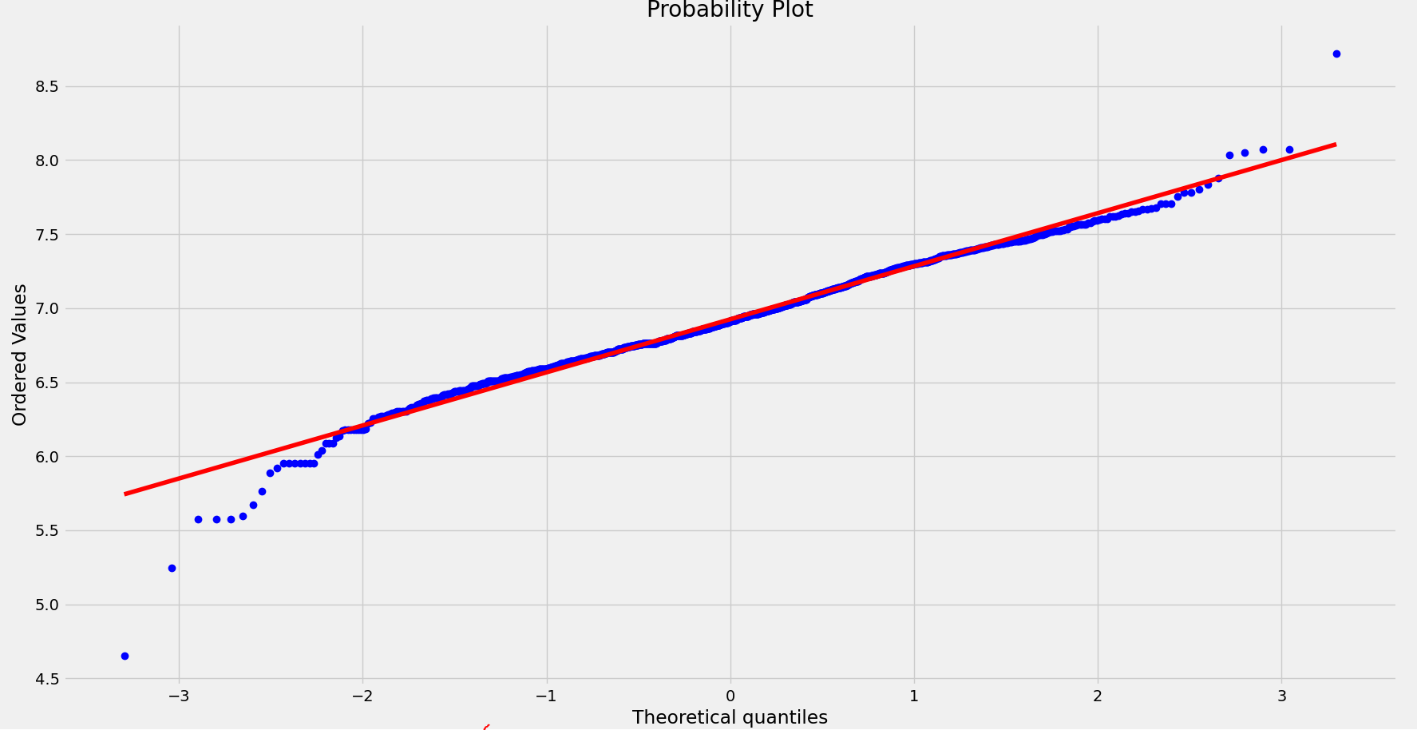

After Scaling:

count 1.460000e+03

mean 2.457699e-16

std 1.000343e+00

min -2.411167e+00

25% -5.966855e-01

50% -1.503334e-01

75% 5.491227e-01

max 1.152095e+01

Skew:1.524254549062765

Kurtosis :13.250483281984796

